**Q1. Explain the Journey of Automotive with the help of flow chart from the Beginning of 18th Century to The 21st Century & give brief description on the following milestones in the Automotive**

**Invention of Electric Motor**

Introduced more than 150 years ago in 19th century , electric cars are seeing a rise in popularity today for many of the same reasons they were first popular.

Designs of electric motors by individuals such as Benjamin Franklin led to ideas for electric vehicles. The invention of the first model electric vehicle is attributed to various people.In 1828, the Hungarian priest and physicist Ányos Jedlik invented an early type of electric motor, and created a small model car powered by his new motor. Between 1832 and 1839, Scottish inventor Robert Anderson also invented a crude electric carriage In 1835, Professor Sibrandus Stratingh of Groningen, the Netherlands and his assistant Christopher Becker from Germany also created a small-scale electric car, powered by non-rechargeable primary cells. \

**Golden Era of EV**

In the U.S., the first successful electric car made its debut around 1890 thanks to William Morrison, a chemist who lived in Des Moines, Iowa. His six-passenger vehicle capable of a top speed of 14 miles per hour was little more than an electrified wagon, but it helped spark interest in electric vehicles.

Over the next few years, electric vehicles from different automakers began popping up across the U.S. New York City even had a fleet of more than 60 electric taxis. By 1900, electric cars were at their heyday, accounting for around a third of all vehicles on the road. During the next 10 years, they continued to show strong sales.

To understand the popularity of electric vehicles circa 1900, it is also important to understand the development of the personal vehicle and the other options available. At the turn of the 20th century, the horse was still the primary mode of transportation. But as Americans became more prosperous, they turned to the newly invented motor vehicle -- available in steam, gasoline or electric versions -- to get around.

Steam was a tried and true energy source, having proved reliable for powering factories and trains. Some of the first self-propelled vehicles in the late 1700s relied on steam; yet it took until the 1870s for the technology to take hold in cars. Part of this is because steam wasn’t very practical for personal vehicles. Steam vehicles required long startup times -- sometimes up to 45 minutes in the cold -- and would need to be refilled with water, limiting their range.

**Domination of Electric Vehicle by Gasoline cars**

As electric vehicles came onto the market, so did a new type of vehicle -- the gasoline-powered car -- thanks to improvements to the internal combustion engine in the 1800s. While gasoline cars had promise, they weren’t without their faults. They required a lot of manual effort to drive -- changing gears was no easy task and they needed to be started with a hand crank, making them difficult for some to operate. They were also noisy, and their exhaust was unpleasant.

Electric cars didn’t have any of the issues associated with steam or gasoline. They were quiet, easy to drive and didn’t emit a smelly pollutant like the other cars of the time. Electric cars quickly became popular with urban residents -- especially women. They were perfect for short trips around the city, and poor road conditions outside cities meant few cars of any type could venture farther. As more people gained access to electricity in the 1910s, it became easier to charge electric cars, adding to their popularity with all walks of life (including some of the “best known and prominent makers of gasoline cars” as a 1911 New York Times article pointed out).

Many innovators at the time took note of the electric vehicle’s high demand, exploring ways to improve the technology. For example, Ferdinand Porsche, founder of the sports car company by the same name, developed an electric car called the P1 in 1898. Around the same time, he created the world’s first hybrid electric car -- a vehicle that is powered by electricity and a gas engine. Thomas Edison, one of the world’s most prolific inventors, thought electric vehicles were the superior technology and worked to build a better electric vehicle battery. Even Henry Ford, who was friends with Edison, partnered with Edison to explore options for a low-cost electric car in 1914, according to Wired.

**Coming of New Era in EV**

Gas shortages spark interest in electric vehicles

Over the next 30 years or so, electric vehicles entered a sort of dark ages with little advancement in the technology. Cheap, abundant gasoline and continued improvement in the internal combustion engine hampered demand for alternative fuel vehicles.

Fast forward to the late 1960s and early 1970s. Soaring oil prices and gasoline shortages -- peaking with the 1973 Arab Oil Embargo -- created a growing interest in lowering the U.S.’s dependence on foreign oil and finding homegrown sources of fuel. Congress took note and passed the Electric and Hybrid Vehicle Research, Development, and Demonstration Act of 1976, authorizing the Energy Department to support research and development in electric and hybrid vehicles.

Environmental concern drives electric vehicles forward

Fast forward again -- this time to the 1990s. In the 20 years since the long gas lines of the 1970s, interest in electric vehicles had mostly died down. But new federal and state regulations begin to change things. The passage of the 1990 Clean Air Act Amendment and the 1992 Energy Policy Act -- plus new transportation emissions regulations issued by the California Air Resources Board -- helped create a renewed interest in electric vehicles in the U.S.

During this time, automakers began modifying some of their popular vehicle models into electric vehicles. This meant that electric vehicles now achieved speeds and performance much closer to gasoline-powered vehicles, and many of them had a range of 60 miles.

One of the most well-known electric cars during this time was GM’s EV1, a car that was heavily featured in the 2006 documentary Who Killed the Electric Car? Instead of modifying an existing vehicle, GM designed and developed the EV1 from the ground up. With a range of 80 miles and the ability to accelerate from 0 to 50 miles per hour in just seven seconds, the EV1 quickly gained a cult following. But because of high production costs, the EV1 was never commercially viable, and GM discontinued it in 2001.

A new beginning for electric cars

While all the starts and stops of the electric vehicle industry in the second half of the 20th century helped show the world the promise of the technology, the true revival of the electric vehicle didn’t happen until around the start of the 21st century. Depending on whom you ask, it was one of two events that sparked the interest we see today in electric vehicles.

The first turning point many have suggested was the introduction of the Toyota Prius. Released in Japan in 1997, the Prius became the world’s first mass-produced hybrid electric vehicle. In 2000, the Prius was released worldwide, and it became an instant success with celebrities, helping to raise the profile of the car. To make the Prius a reality, Toyota used a nickel metal hydride battery -- a technology that was supported by the Energy Department’s research. Since then, rising gasoline prices and growing concern about carbon pollution have helped make the Prius the best-selling hybrid worldwide during the past decade.

The other event that helped reshape electric vehicles was the announcement in 2006 that a small Silicon Valley startup, Tesla Motors, would start producing a luxury electric sports car that could go more than 200 miles on a single charge. In 2010, Tesla received at $465 million loan from the Department of Energy’s Loan Programs Office -- a loan that Tesla repaid a full nine years early -- to establish a manufacturing facility in California. In the short time since then, Tesla has won wide acclaim for its cars and has become the largest auto industry employer in California.

Tesla’s announcement and subsequent success spurred many big automakers to accelerate work on their own electric vehicles. In late 2010, the Chevy Volt and the Nissan LEAF were released in the U.S. market. The first commercially available plug-in hybrid, the Volt has a gasoline engine that supplements its electric drive once the battery is depleted, allowing consumers to drive on electric for most trips and gasoline to extend the vehicle’s range. In comparison, the LEAF is an all-electric vehicle (often called a battery-electric vehicle, an electric vehicle or just an EV for short), meaning it is only powered by an electric motor.

Over the next few years, other automakers began rolling out electric vehicles in the U.S.; yet, consumers were still faced with one of the early problems of the electric vehicle -- where to charge their vehicles on the go. Through the Recovery Act, the Energy Department invested more than $115 million to help build a nation-wide charging infrastructure, installing more than 18,000 residential, commercial and public chargers across the country. Automakers and other private businesses also installed their own chargers at key locations in the U.S., bringing today’s total of public electric vehicle chargers to more than 8,000 different locations with more than 20,000 charging outlets.

At the same time, new battery technology -- supported by the Energy Department’s Vehicle Technologies Office -- began hitting the market, helping to improve a plug-in electric vehicle’s range. In addition to the battery technology in nearly all of the first generation hybrids, the Department’s research also helped develop the lithium-ion battery technology used in the Volt. More recently, the Department’s investment in battery research and development has helped cut electric vehicle battery costs by 50 percent in the last four years, while simultaneously improving the vehicle batteries' performance (meaning their power, energy and durability). This in turn has helped lower the costs of electric vehicles, making them more affordable for consumers.

The future of electric cars

It’s hard to tell where the future will take electric vehicles, but it’s clear they hold a lot of potential for creating a more sustainable future. If we transitioned all the light-duty vehicles in the U.S. to hybrids or plug-in electric vehicles using our current technology mix, we could reduce our dependence on foreign oil by 30-60 percent, while lowering the carbon pollution from the transportation sector by as much as 20 percent.

**Introduction to Hybrid Electric vehicles**

Consumers now have more choices than ever when it comes to buying an electric vehicle. Today, there are 23 plug-in electric and 36 hybrid models available in a variety of sizes -- from the two-passenger Smart ED to the midsized Ford C-Max Energi to the BMW i3 luxury SUV. As gasoline prices continue to rise and the prices on electric vehicles continue to drop, electric vehicles are gaining in popularity -- with more than 234,000 plug-in electric vehicles and 3.3 million hybrids on the road in the U.S. today.

What's the Difference?

A hybrid electric vehicle (or HEV for short) is a vehicle without the capacity to plug in but has an electric drive system and battery. It's driving energy comes only from liquid fuel. Learn about the history of the hybrid -- from the world's first one to the world's best selling one.

A plug-in hybrid electric vehicle (also called a PHEV) is a vehicle with plug-in capability, and it can use energy for driving from either its battery or liquid fuel. Read about the first commercially available plug-in hybrid.

**Q2. Explain and Draw the Layout of following Hybrid Electric vehicles with their two Advantages, Disadvantages & Industrial application in automotive segment?**

**a) Series Hybrid Electric vehicles**

**b) Parallel Hybrid Electric vehicles**

**c) Series Parallel Hybrid vehicle**

**d) Plug in Hybrid electric vehicle**

**e) Fuel Cell Electric Vehicle**

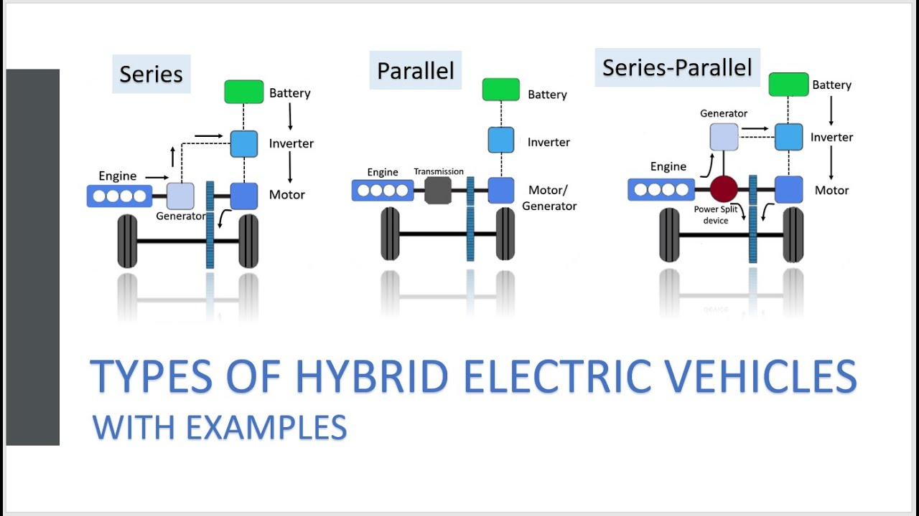

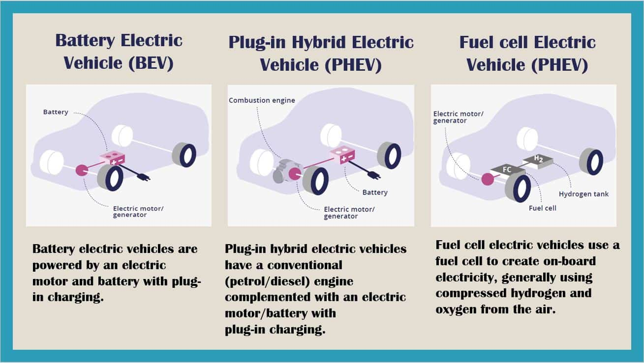

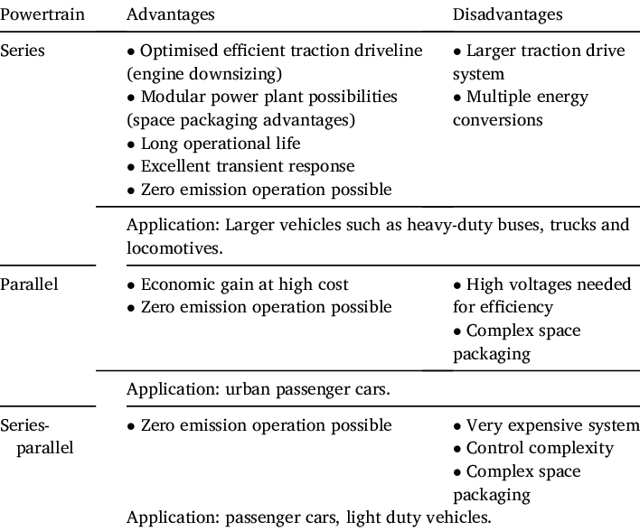

**Q3. Explain with Diagram the Construction & Working principle of Brushless Motor BLDC?**

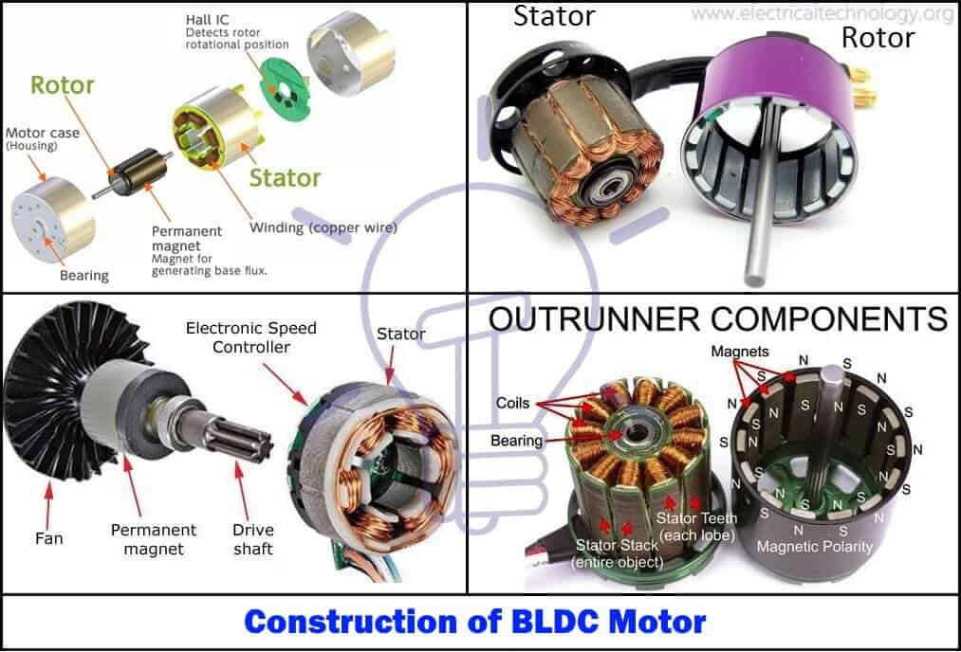

**Working Principle and Operation of BLDC Motor**

BLDC motor works on the principle similar to that of a conventional DC motor, i.e., the Lorentz force law which states that whenever a current carrying conductor placed in a magnetic field it experiences a force. As a consequence of reaction force, the magnet will experience an equal and opposite force. In case BLDC motor, the current carrying conductor is stationary while the permanent magnet moves.

[[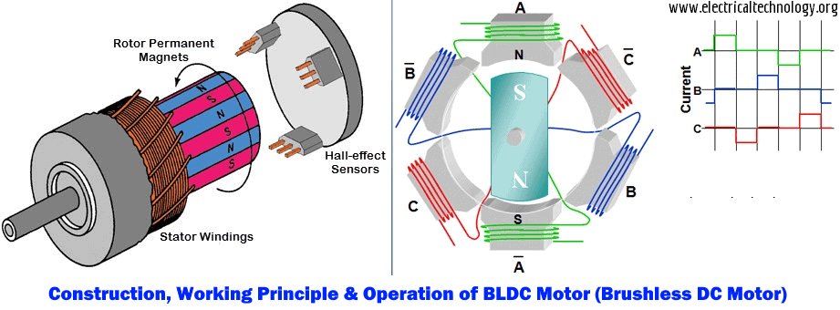](https://www.electricaltechnology.org/wp-content/uploads/2016/05/Construction-Working-Principle-and-Operation-of-BLDC-Motor-Brushless-DC-Motor.png)](https://www.electricaltechnology.org/wp-content/uploads/2016/05/Construction-Working-Principle-and-Operation-of-BLDC-Motor-Brushless-DC-Motor.png)

When the stator coils are electrically switched by a supply source, it becomes electromagnet and starts producing the uniform field in the air gap. Though the source of supply is DC, switching makes to generate an AC voltage waveform with trapezoidal shape. Due to the force of interaction between electromagnet stator and permanent magnet rotor, the rotor continues to rotate.

Consider the figure below in which motor stator is excited based on different switching states. With the switching of windings as High and Low signals, corresponding winding energized as North and South poles. The permanent magnet rotor with North and South poles align with stator poles causing motor to rotate.

Observe that motor produces torque because of the development of attraction forces (when North-South or South-North alignment) and repulsion forces (when North-North or South-South alignment). By this way motor moves in a clockwise direction.

[[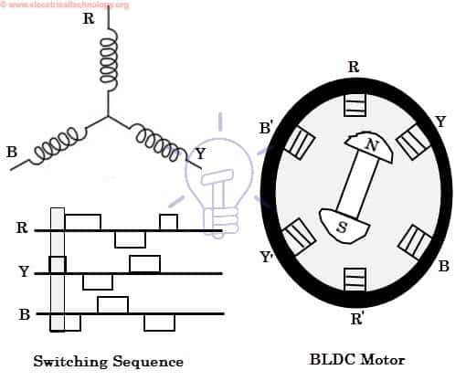](https://www.electricaltechnology.org/wp-content/uploads/2016/05/BLDC-motor-operation.jpg)](https://www.electricaltechnology.org/wp-content/uploads/2016/05/BLDC-motor-operation.jpg)

Here, one might get a question that how we know which stator coil should be energized and when to do. This is because; the motor continuous rotation depends on the switching sequence around the coils. As discussed above that Hall sensors give shaft position feedback to the electronic controller unit.

Based on this signal from sensor, the controller decides particular coils to energize. Hall-effect sensors generate Low and High level signals whenever rotor poles pass near to it. These signals determine the position of the shaft.