# Questions 1 - Mesh the Geometry

**Geometry Detail’s**

* Mesh the cylindrical PIPE as per the given instructions
* Dimension for PIPE

1. Diameter of pipe= 60mm
2. Length of pipe= 300mm

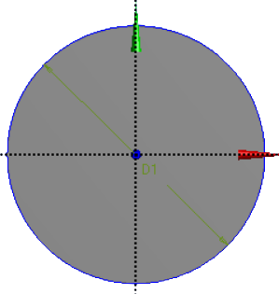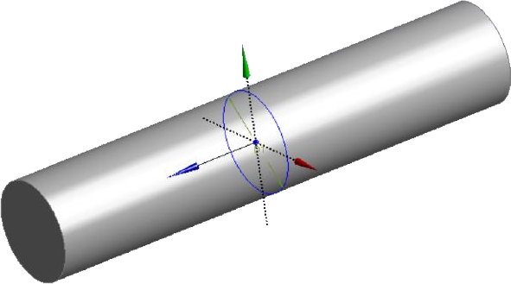

* Decompose it into Following parts

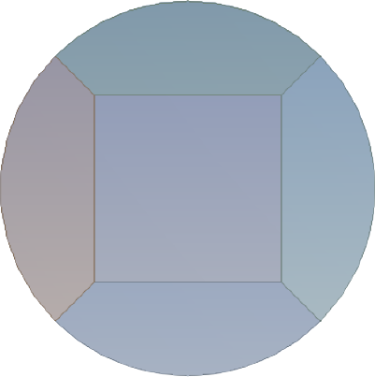

**1**

**2**

**5**

**4**

**3**

* + *After decomposition 5 parts will be there with different colour*

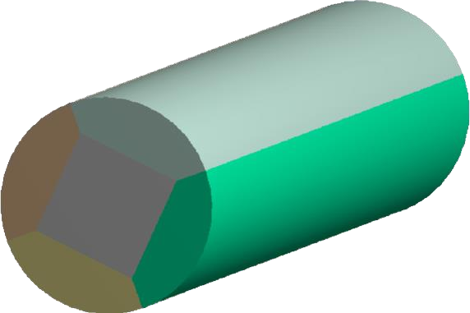

# Meshing Details

* 1. Meshing Methods= Tetrahedrons (Patch Conforming)
  2. Body Sizing
  3. Element Size= 2mm

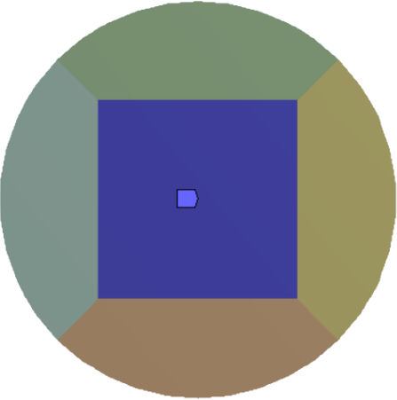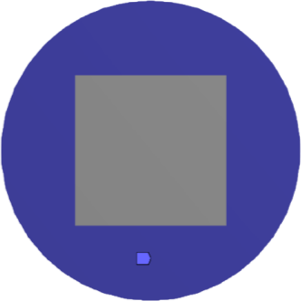

# Inflation layer

1. Max layer=10
2. Growth-rate=1.2

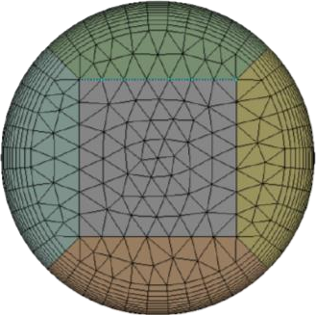

# Submissions

1. You need to make a report like this including following details
2. All the images of geometry with the Dimensions given (Front view, side view, top view) after decomposing it
3. Details of Meshing with Mesh methods body sizing inflation layer details & Mesh statistic
4. Mesh quality parameter should be there (Graphs of Skewness, Element quality, Orthogonal Quality)

***Note*** *Use snipping tool to capture images*

REPORT OF THE WORK DONE

Meshed the cylindrical PIPE as per the given instructions

* Dimension for PIPE

1. Diameter of pipe= 60mm
2. Length of pipe= 300mm

The different views of the cylindrical pipe are as given below:

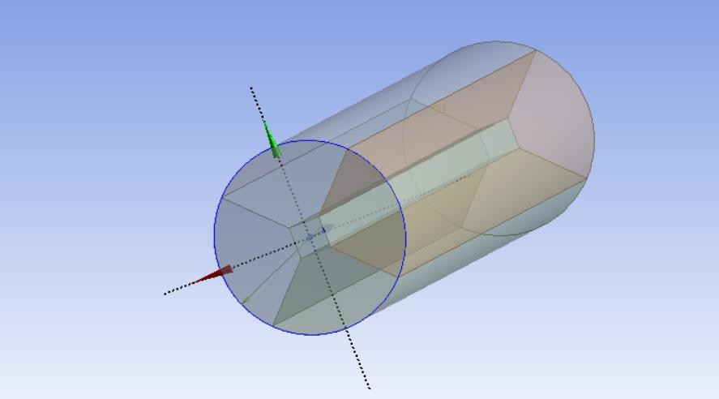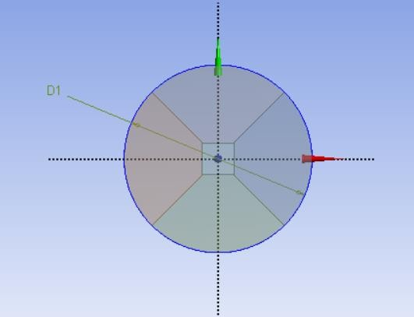

Fig 2 : Isometric View of the PIPE

Fig 1 : Front View of the PIPE

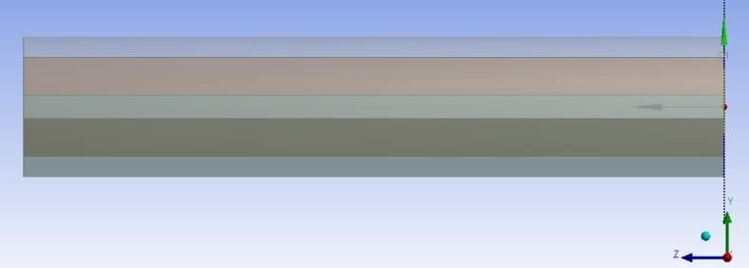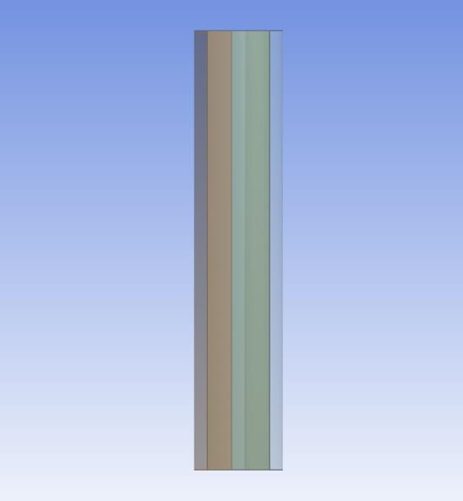

Fig 5 : Side View of the PIPE

Fig 4 : Bottom View of the PIPE

Fig 3 : Top View of the PIPE

Decomposed View

# Meshing Details

* 1. Meshing Methods= Tetrahedrons (Patch Conforming)
  2. Body Sizing
  3. Element Size= 2mm

The meshing was done by Tetrahedrons method and in that Patch Conforming was done with an element size of 2mm.The number of nodes was found to be 1317867 and the number of elements was found to be 962562.

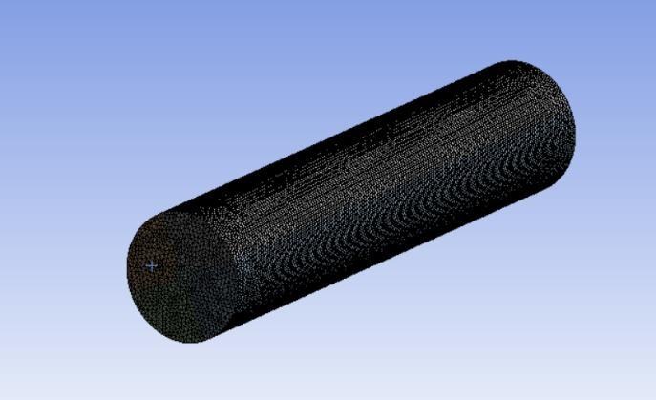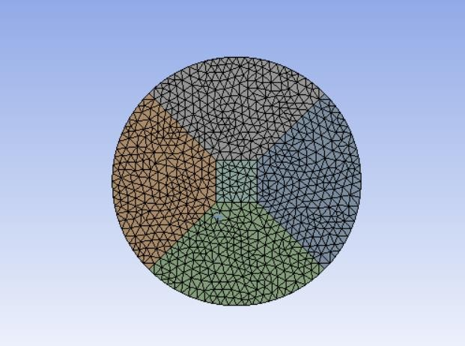The different views of the PIPE after Tetrahedron meshing method was used are given below:

Fig 1 : Front View of the PIPE

Fig 2 : Isometric View of the PIPE

## Inflation layer

Max layer=10

Growth-rate=1.2

The mesh quality parameters are determined based on the skewness, element quality and orthogonal quality. The findings and the graphical representations are as shown below:

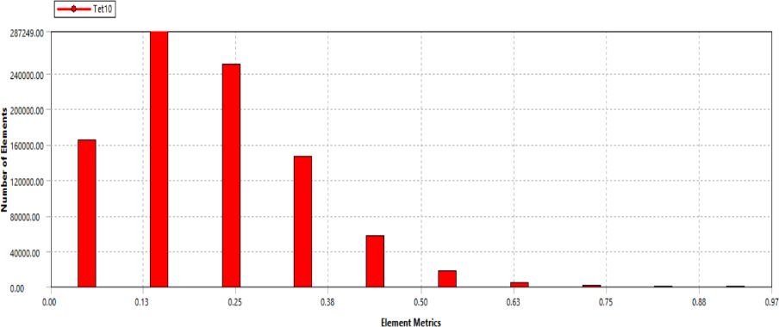**1.Skewness**

This is the graphical representation of the skewness.

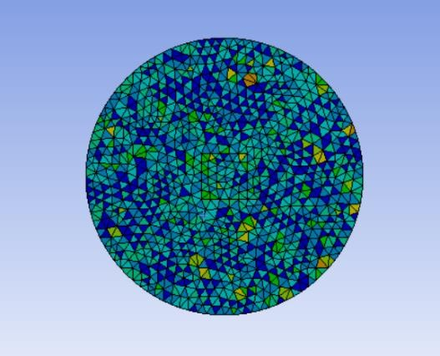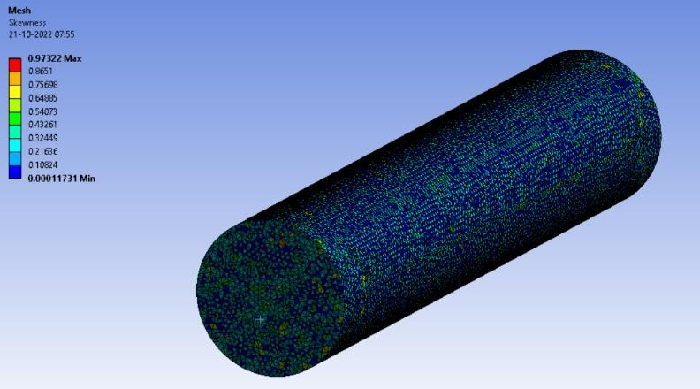The different views are as shown below:

Fig 2: Front View of the PIPE

Fig 1: Isometric View of the PIPE

**2.Element Quality:**

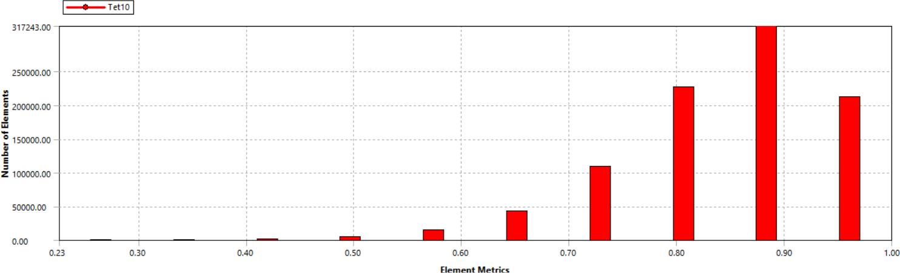

This is the graphical representation of the Element Quality.

The different views are as shown below:

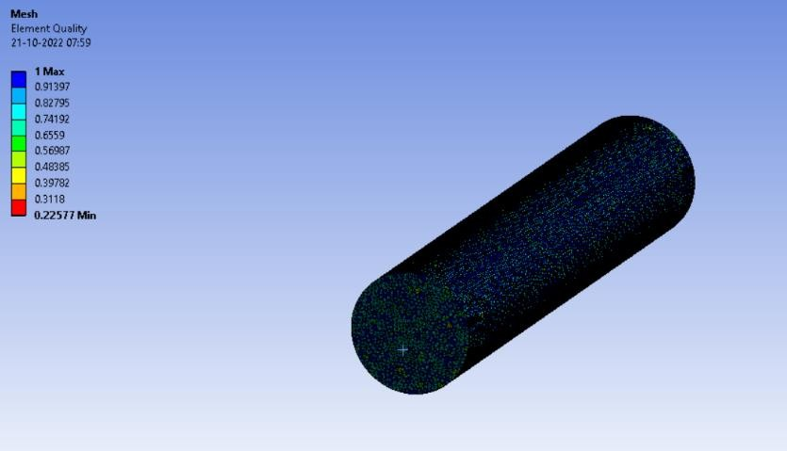

Fig 2: Front View of the PIPE

Fig 1: Isometric View of the PIPE

**3.Orthogonal Quality:**

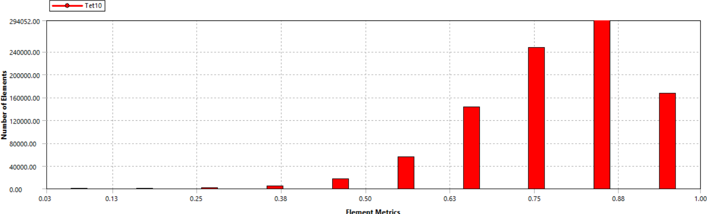

This is the graphical representation of the Orthogonal Quality.

The different views are as shown below:

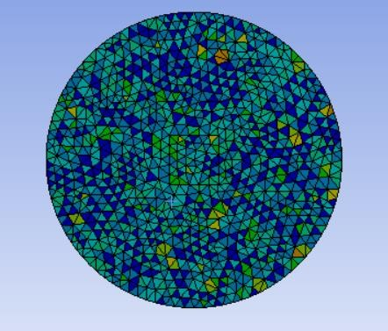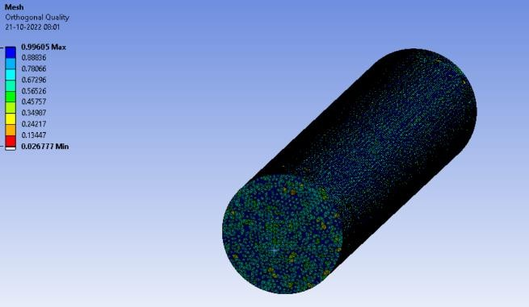

Fig 2: Front View of the PIPE

Fig 1: Isometric View of the PIPE

# Question 2: Static Structural Analysis

# Meshing Details

1. Meshing Methods= Automatic
2. Body Sizing
3. 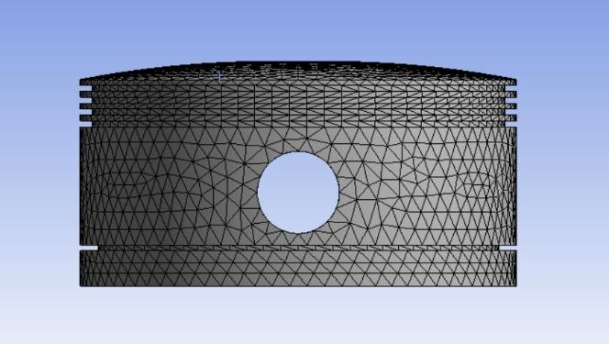Element Size= 3mm

The material used was structural steel and a frictionless support was provided. This was the boundary condition.

Pressure: 5Mpa

When a pressure of 5 Mpa is applied,

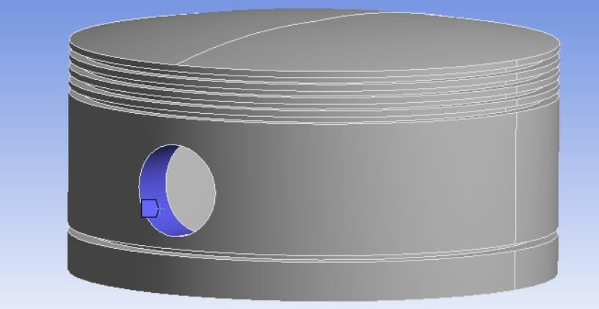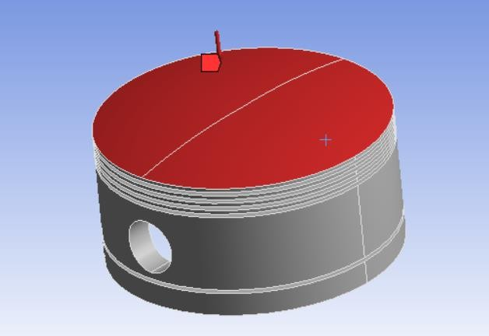

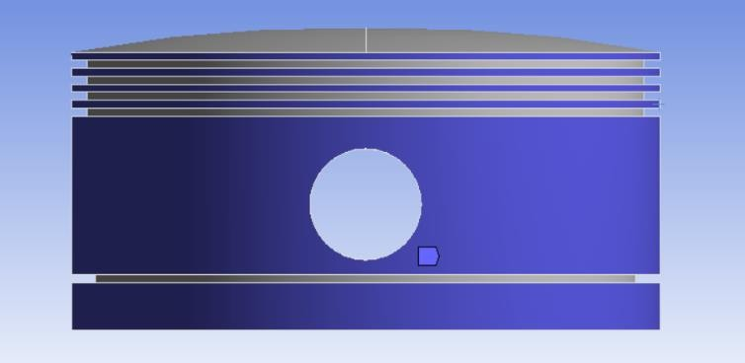The images of frictionless support is as shown below

Fig 2: Front View of the Geometry

Fig 1: Isometric View of the Geometry

Our aim is to find the total deformation and directional deformation.

1. **Total Deformation**

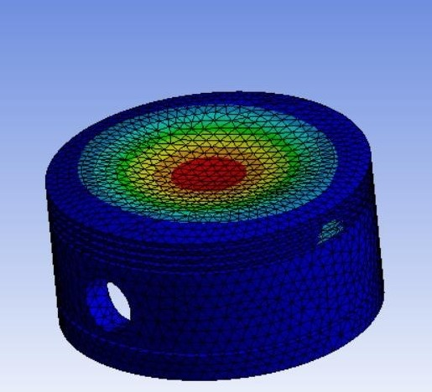

1. **Directional Deformation**

